**Skybox**

**Objective:** We’re going to add a skybox!

1. Create material and name it **Skybox**.
2. Go to the Inspector and find the **Shader** dropdown menu. Change it from **Standard** to **Skybox** **->** **Procedural.**
3. Change the **Sky Tint** color and drag the asset on to your Sky in the **Scene** window.

Creating a six sided sky box

1. Go to the asset store and find a free skybox asset or make your own!

<https://assetstore.unity.com/packages/2d/textures-materials/sky/skybox-volume-2-nebula-3392>

1. If we go back to where our Skybox Volume 2 material in the assets folder and open one of them, you can see there's a slot for front, there's a slot for back, and left and so on.
2. So I'm going to go back up to my assets level here. Find my Skybox and **change it from procedural to six-sided**.

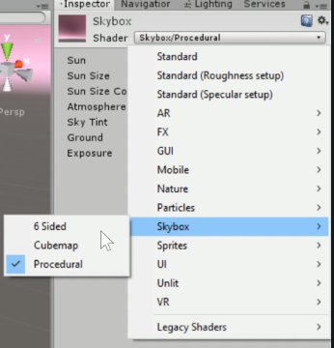

Basically, the Skybox is the thing that's sitting around the whole world. And rather than modeling a nice big smooth sphere, we put six sides on a cube on a box around the world and blend them together so that it looks nice and seamless.

This Skybox goes one step further. Thank you very much to the creators of this. They've got a DSGWP already created in here as a material. So I can just go and drag that straight onto my Skybox and boom, look, all of a sudden, our game is looking really different, really cool, really amazing.

1. If you do go to the asset store change the Shader to Skybox/6 sided, import the Skybox and drag and drop on to your scene.

**Background**: Basically, the Skybox is the thing that's sitting around the whole world. And rather than modeling a nice big smooth sphere, we put six sides on a cube on a box around the world and blend them together so that it looks nice and seamless.